**Hero Page**

**Banner 1**

Affiliated to 3000+ Multispecialty and super specialty hospital for training

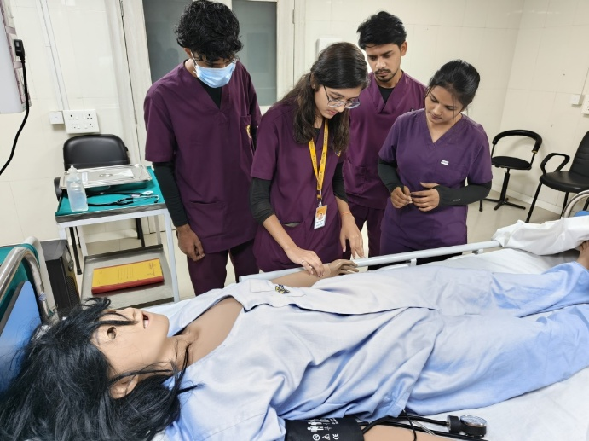

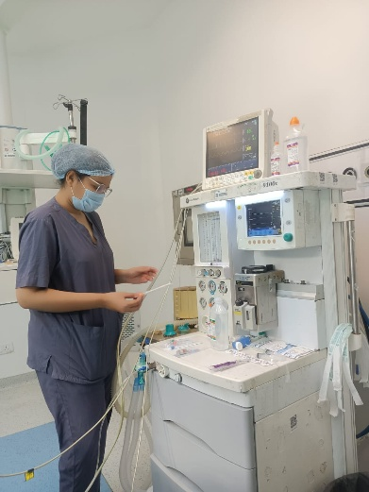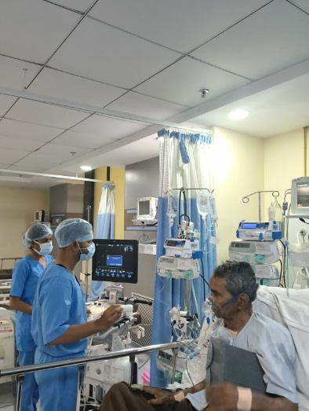

**Banner 2**

Maharashtra Paramedical Council Approved Programs

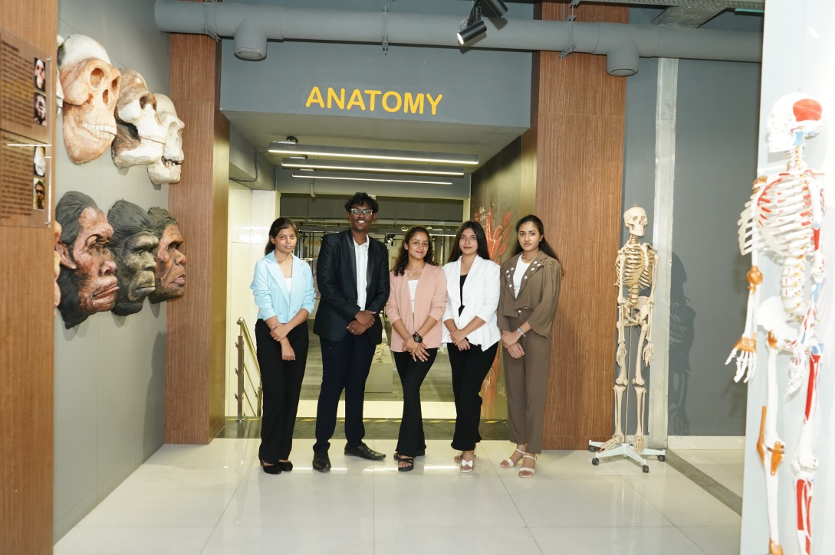

**Banner 3**

24 UG, 15 PG Programs and 2500+ Allied Health Students enrolled

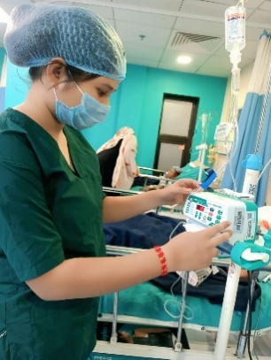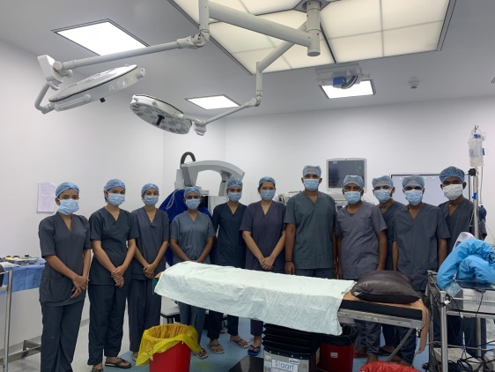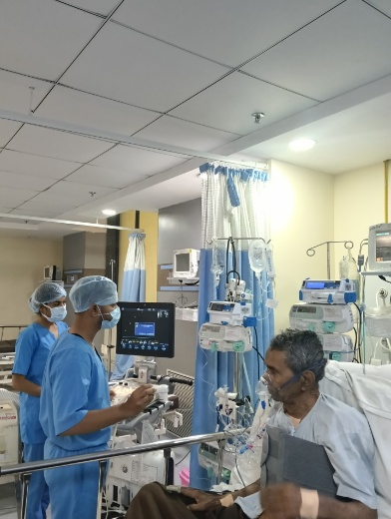

**Banner 4:**

NEP aligned curriculum with Academic Flexibility

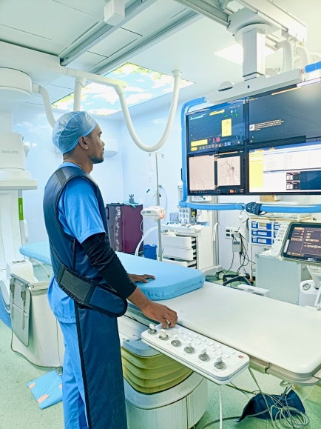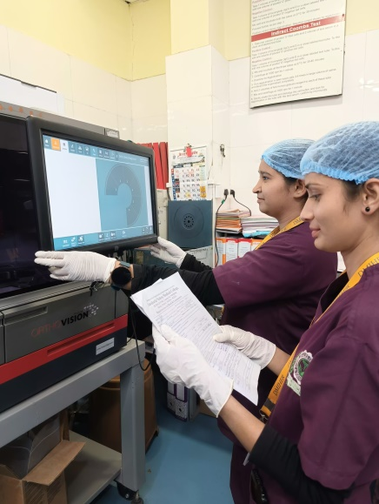

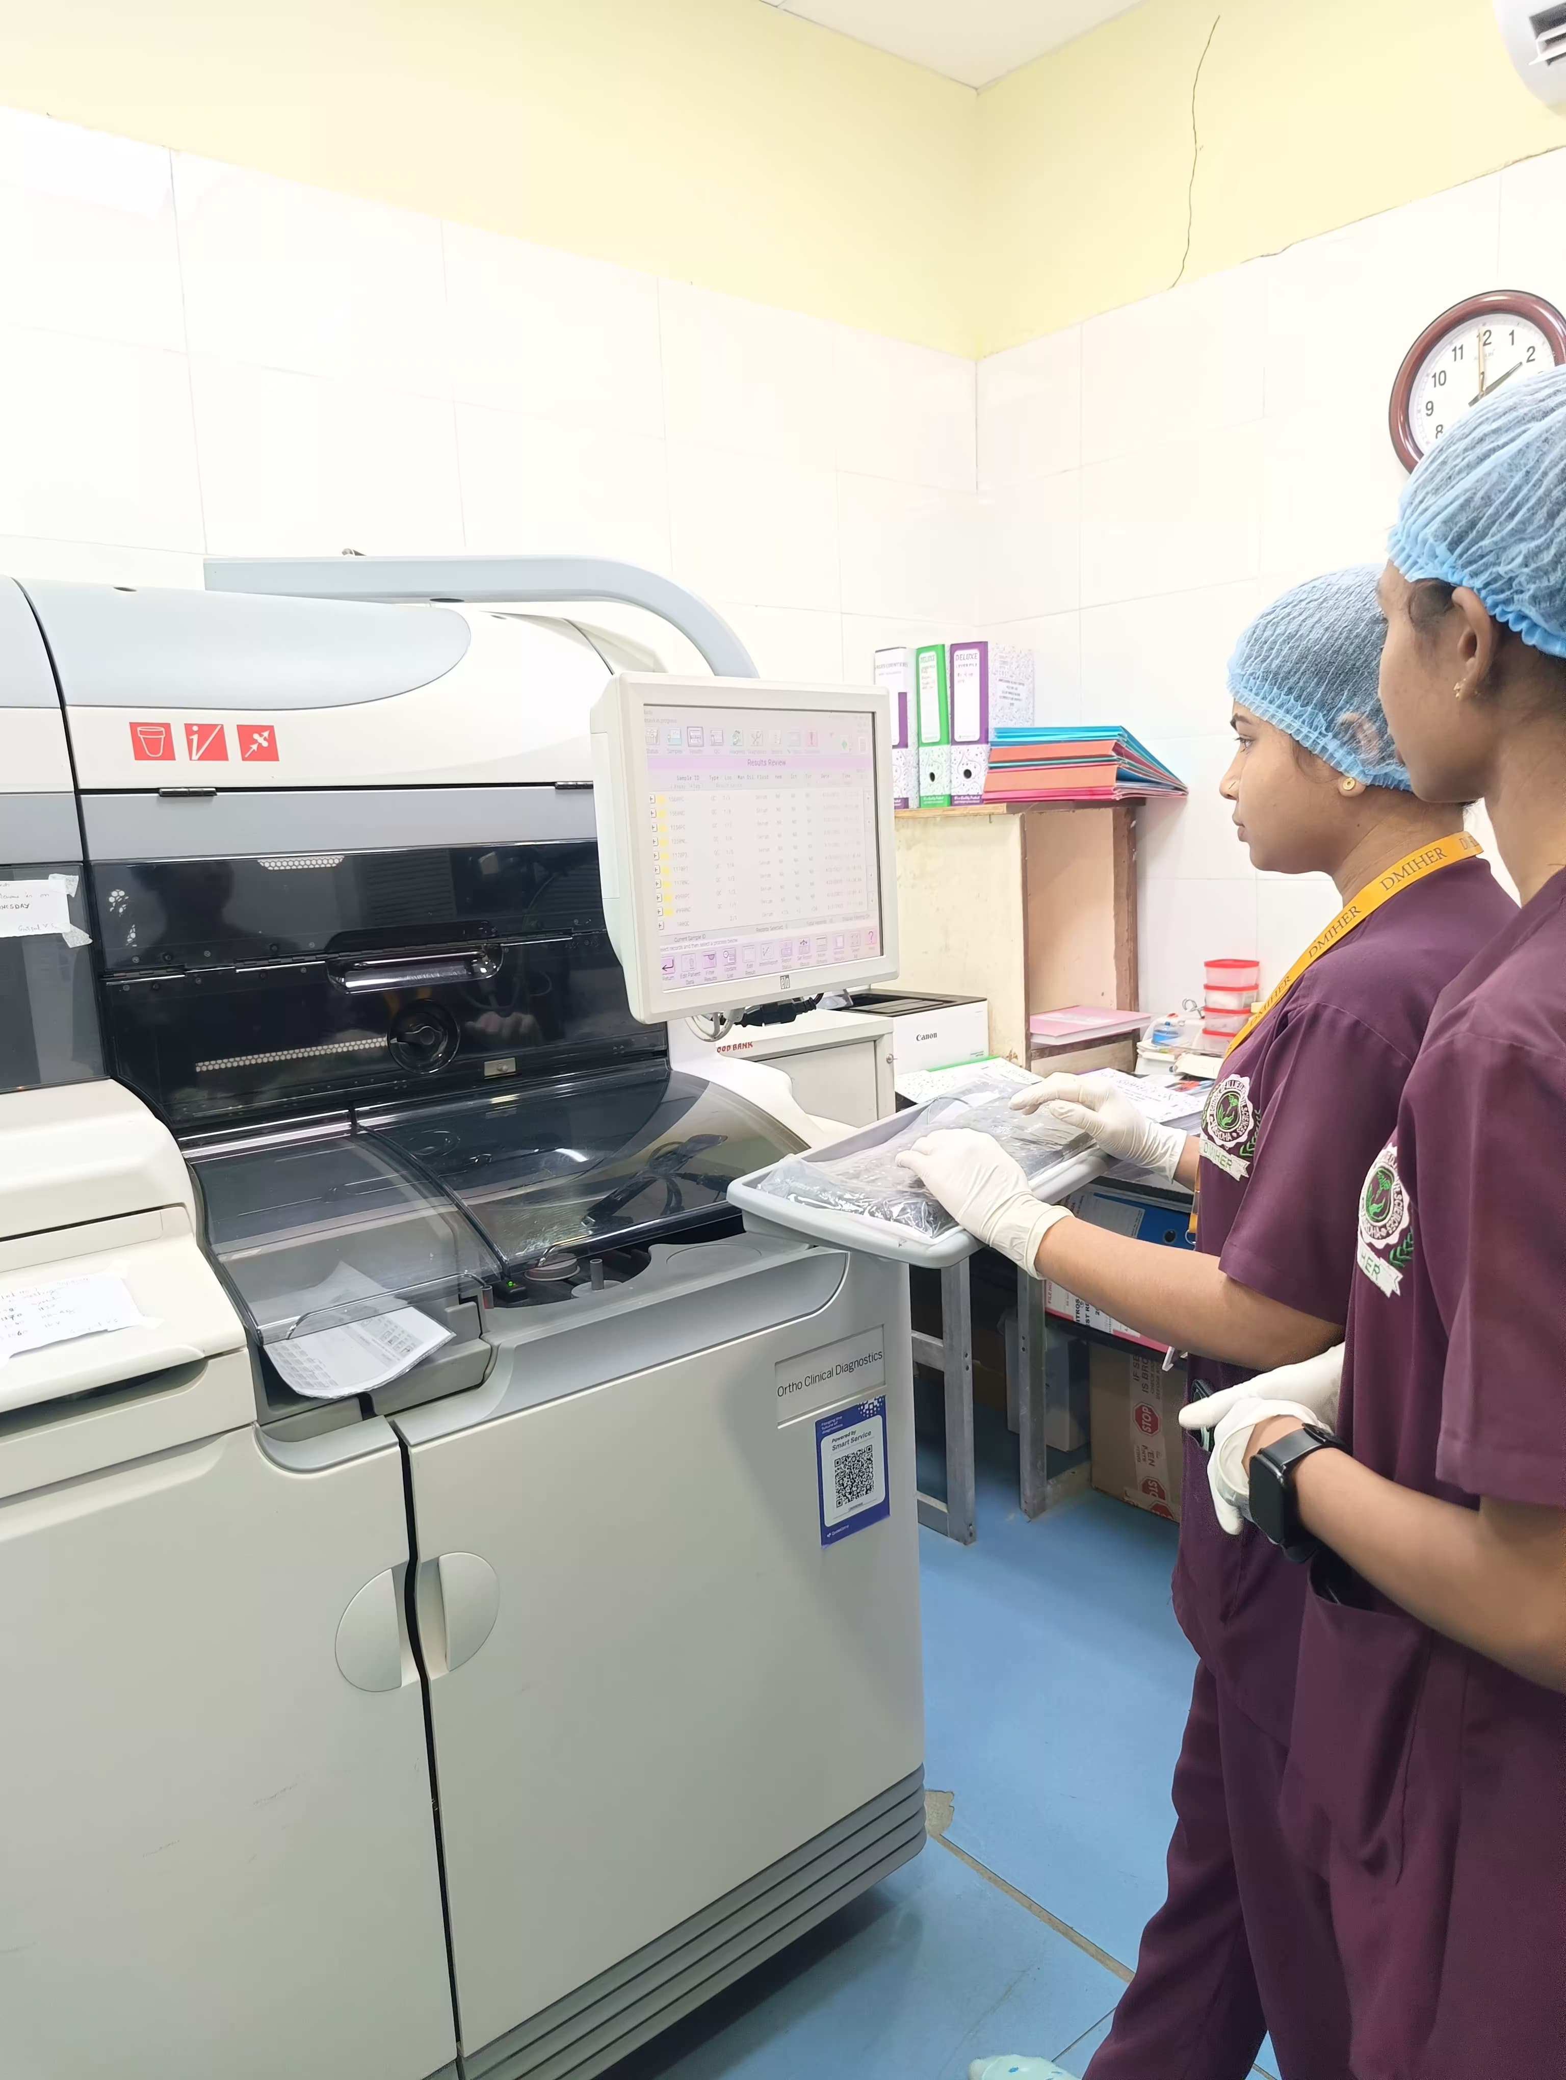

**On page**

**School of Allied Health Sciences (SAHS)**

*Bridging Healthcare Gaps. Building Future-Ready Professionals.*

At the intersection of science, care, and technology The **School of Allied Health Sciences (SAHS)**, was established in 2018 by **Datta Meghe Institute of Higher Education & Research (DMIHER)**, as a pioneering initiative designed to meet the growing demand for skilled healthcare professionals who work alongside doctors and specialists—delivering critical diagnostic, therapeutic, and preventive services.

With a clear mission to develop comprehensively trained, globally competent allied health professionals across multiple domains, the two campuses in **Wardha** and **Nagpur,** are training a new generation of Allied Health Professionals (AHPs) who are shaping the future of integrated, patient-centered care. Emerging as one of Central India’s most dynamic hubs for allied health education, the campuses offer a wide spectrum of programs backed by interdisciplinary training, NEP-aligned curricula, and extensive clinical exposure through DMIHER’s 1,500+ bedded specialty and super-specialty hospitals.

With over **2,500 students enrolled**, the SAHS’s ecosystem encourages hands-on learning, research, innovation, and global immersion through **international pathway and semester-abroad programs**.

**Programs** at **SAHS Wardha**: **24 Undergraduate** I **13 Postgraduate** I **4 Ph.D. programs** I **1 Diploma** I **2 Postgraduate Executive**, and **6 Executive Development Programs**

**Programs** at **SAHS Nagpur**: **22 Undergraduate** I **12 Postgraduate** I **2 Postgraduate Executive** I **4 Executive Development**

**Areas of Study Across Both Campuses Include:**  
Life Sciences | Trauma Care | Ophthalmic Sciences | Medical Imaging & Radiology | Surgical & Anesthesia Tech | Nutrition | Neuroscience | Renal Technology | Behavioral Sciences | Health & Information Management | Physician Assistant | Respiratory Therapy and more.

**Why choose SAHS?**

1. Skill based training through Internship and Apprenticeship I Collaborations with top hospitals of the country
2. Real-time training at Hospitals, diagnostic Centres Skill labs, advanced lab equipment, simulation tools, and clinical mentorship
3. International exposure through Pathway and semester abroad I 100 % placement assistance
4. Super specialist and Specialist Doctors for teaching and training
5. Skill based training through Internship and Apprenticeship

Next section

Dean’s Message

Below this we will have both campuses to click and see message. Horizontal scroll.

SASH Wardha I SASH Wana

As we click the entire leadership page of the institute opens.

Next section

Like in all institutes, we will have programs link

SASH Wardha

UG I PG I Ph.D. I Executive Development

SASH Wana

UG I PG

Next section

Associated Hospital

Below this we will have both campuses to click and see message. One will be open by default. Horizontal scroll.

SASH Wardha I SASH Wana

SASH Wardha

Acharya Vinoba Bhave Rural Hospital (AVBRH), Wardha

*A 1,500+ Bedded Ecosystem for Real-World Learning*

AVBRH is one of Central India’s largest teaching hospitals, providing Allied Health Sciences students with unmatched clinical exposure. From diagnostics to surgical care, students train alongside specialists, gaining hands-on experience in real-time patient settings.

Its multidisciplinary setup, community outreach, and state-of-the-art facilities foster critical thinking, clinical skills, and professional confidence—preparing students to meet real-world healthcare challenges with competence and compassion.

[Know More]

SASH Wana

Shalinitai Meghe Hospital & Research Centre (SMHRC), Wana, Nagpur

*Advanced Care. Applied Learning.*

SMHRC is a modern multi-super specialty hospital and the clinical training ground for SAHS Wana. Students engage in active care across high-end diagnostic and therapeutic settings under the guidance of expert doctors. With leading infrastructure and a strong focus on equitable healthcare, SMHRC shapes students into skilled, ethical, and empathetic professionals—ready to serve diverse patient needs in a fast-evolving health landscape.

[Know More]

Next section

***Next section***

***This section will have the click to show relevant campus***

SASH Wardha I SASH Wana

SASH Wardha

**Holistic Learning and Infrastructure**

Tabs – with text on left and changing visuals on right

**Teaching–Learning Facilities**

ICT-enabled classrooms I Learning Management SystemI State-of-the-art auditorium

**Advanced Skills & Simulation**

**Anukruti – Skill to Heal**: Clinical Competency Training I Hands-on simulation-based learning for real-time decision-making I Bridge theory with real-world clinical scenarios. Students actively train in:

• Emergency Medicine | Interventional Radiology (IR) | Operation Theatres (OT)

• Anesthesia Technology | Blood Bank Technology | Cardiopulmonary Bypass (CPB) Machine

**School of Experiential Learning & Simulation Centre (SEL & SC)**: Immersive Simulation and Virtual Learning I Real-life scenario-based modules I Interprofessional learning I Diverse healthcare settings through structured, monitored exposure

**JIGYASA – The Curious Brain (Central Museum)**:Self-Directed Learning I Life-size anatomical models, preserved specimens, charts, and digital learning tools I Integrated understanding of human structure and function across specialties

**Hospital Facilities:**

1,500+ bedded Hospital (AVBRH), advanced ICUs, specialty OTs, diagnostic and interventional departments, extensive in-patient and out-patient exposure across departments, and hands-on experience under supervision of seasoned clinical faculty

Students gain competencies in:

• Intensive Care | OT & Emergency | Yoga & Naturopathy | Clinical Labs & Diagnostics

SASH Wana

**Holistic Learning and Infrastructure**

*Tabs – with text on left and changing visuals on right*

**Teaching–Learning Facilities**

ICT-enabled classrooms I Learning Management System I Smart, self-directed academic spaces

**Advanced Skills & Simulation**

**Anubhuti – School of Experiential Learning & Simulation Centre:** Centre of Excellence for clinical skills training I Hands-on simulation-based learning for real-world application I Bridge theory with practice through immersive, scenario-based modules

Students actively train in:

Emergency Medicine | Dialysis | CT Scan | MRI Console

**Svaadhyaay – The Integrated Museum:** Self-learning ecosystem I Anatomical specimens, models, charts, and digital tools I Enables deep understanding of human structure and function across specialties

**Hospital Facilities**

Shalinitai Meghe Hospital & Research Centre (SMHRC) – Multi-super specialty, tech-enabled hospital I National and international standards I Broad in-patient and out-patient exposure I Advanced diagnostics and specialty care units I Immersive clinical learning under expert supervision

Students gain competencies in:

Emergency Medicine | Diagnostic Imaging | Dialysis | MRI & CT Scan

Next section

Transcripts Link for both campuses

***Next Section:***

Our Departments – these are designs with blocks and also links

SASH Wardha I SASH Wana

SASH Wardha

**Radiology I Radiotherapy I Pathology I Medicine I Respiratory Medicine I Dermatology I Physiology I Cardiology I Cardio Vascular Surgery I Nephology I Neurosciences I Surgery I Anaesthesia I Emergency Medicine I Orthopedics I Anesthesia I Ophthalmology I Pathology I MGAC I AHS I Clinical Nutrition and Dietetics I Psychology**

SASH Wana

**Radiology I Pathology I Medicine I Respiratory Medicine I Dermatology I Physiology I Cardiology I Cardio Vascular Surgery I Nephology I Neurosciences I Surgery I Anaesthesia I Emergency Medicine I Orthopaedics I Anaesthesia I Ophthalmology I Pathology I AHS I Clinical Nutrition and Dietetics I Psychology**

Next section

**Collaborations**

*Powered by Partnerships. Defined by Opportunity.*

SAHS partners with top hospitals, global universities, and leading healthcare academies to offer real-world training, global exposure, and skill-based learning. These alliances drive clinical excellence, academic depth, and industry readiness.

**National Developmental Partners (Logos)**

1. Asian Institute of Gastroenterology, Hyderabad
2. ALPS (MAX Health Care Ltd, New Delhi
3. National Cancer Hospital, Nagpur
4. LENSKART EYETECH PVT. LTD, New Delhi
5. Lifenity Health Limited, Pune
6. ADCC Academy Private Limited Nagpur
7. AIIMS Hospital, Nagpur
8. Hinduja Hospital, Nagpur
9. KIMS Kingsway Hospital, Nagpur
10. HCG, Nagpur
11. Wockhardth Hospital, Nagpur
12. Mahatme Eye Hospital, Nagpur

**International Developmental Partners (Logos)**

1. BAPIO Training Academy, UK
2. Leeds Bucket University, UK
3. Kartz School, Yeshiva University, USA

**Skills and Knowledge Partner: Max Healthcare Education**

Datta Meghe Institute of Higher Education & Research (DMIHER), in collaboration with Max Healthcare Education, offers specialized Allied Health Sciences programs in apprenticeship embedded mode which are designed to equip students with the skills and knowledge required for a successful career in healthcare. This partnership combines DMIHER's academic excellence with Max Healthcare's extensive clinical expertise, providing students with a comprehensive learning experience.

Know More about MAX Advantage & Programs offered

Next section

**Global Opportunities at SAHS**

SAHS opens pathways to global education through semester-abroad programs, international degree transitions, and placement opportunities with renowned global partners.

**MS BME (Biotechnology, Management and Entrepreneurship) program at Yeshiva University, USA I Semester abroad for M.Sc. Clinical Nutrition and Dietetics at Leeds Bucket University, USA. I International Placement Opportunities for the Students through BAPIO Training Academy, Bedford, UK**

Next section

**Placements – National and International**

SAHS graduates are recruited by leading healthcare institutions in India and abroad, with prominent international placements through NHS trusts in the UK. Backed by hands-on clinical training and industry-aligned programs, our students are prepared for high-impact roles from day one.  
The **median package for international placements** currently stands at **₹35,00,000**, reflecting the global value of a DMIHER Allied Health Sciences education.

Put logos

Next section

Alumni Link

Next section

**Student Life at SAHS**

At SAHS, student life goes far beyond the classroom. A vibrant mix of academic clubs, cultural forums, and wellness initiatives ensures holistic growth and community engagement. From literary circles and quiz clubs to sports, music, art, and theatre—every student finds a space to express, lead, and thrive.

Workshops, fests, intercollegiate competitions, and national celebrations like *Bharatiya Bhasha Utsav* or *Self-Defence Drives* add depth to campus life—instilling confidence, creativity, and collaboration. The National Service Scheme and Social Welfare Clubs foster a strong sense of responsibility and purpose, shaping not just healthcare professionals, but compassionate citizens.

Gallery

Testimonials section as all other institutions pages, here, we will have link to both campuses followed by the chosen institutions content

**Testimonials (Add this section as well)**